Sporting PRE Soccer Reader T-shirt
Order Form

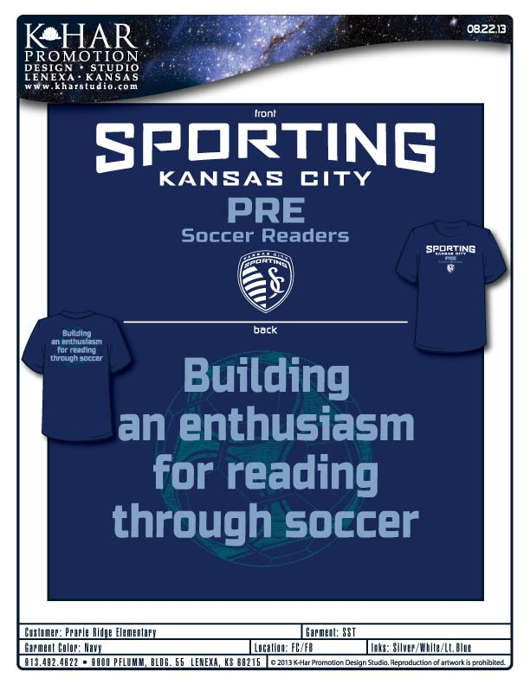
Cost: $7.00
Sizes: Youth Small, Youth Medium, Youth Large, Adult Small, Adult Medium, Adult Large
Cash or Checks Made Payable to: K-Har Studio
Student Name _________________________ Size _____________

All t-shirt order forms and money need to be returned to Mrs. Leggett by September 11, 2013

